Experiment 39: Vehicle Detection in a Video Frame using OpenCV
Software / Tools: Python · OpenCV (cv2)

AIM
To detect vehicles (cars) in a video frame/image using a pre-trained Haar Cascade classifier for cars.
ALGORITHM
1. Import OpenCV.
2. Load a pre-trained car/vehicle Haar Cascade XML file (e.g. cars.xml).
3. Read the video using cv2.VideoCapture() (or a single frame/image).
4. Convert each frame to grayscale.
5. Call detectMultiScale() on the grayscale frame to get bounding boxes of detected vehicles.
6. Draw rectangles around each detected vehicle.
7. Display the annotated frame; repeat for each frame of the video.
PROGRAM (SOURCE CODE)
import cv2

car_cascade = cv2.CascadeClassifier("cars.xml")
cap = cv2.VideoCapture("traffic_video.mp4")

while True:
ret, frame = cap.read()
if not ret:
break

gray = cv2.cvtColor(frame, cv2.COLOR_BGR2GRAY)
cars = car_cascade.detectMultiScale(gray, scaleFactor=1.05, minNeighbors=3, minSize=(40, 40))

for (x, y, w, h) in cars:
cv2.rectangle(frame, (x, y), (x + w, y + h), (0, 0, 255), 3)
cv2.putText(frame, "Vehicle", (x, y - 8), cv2.FONT_HERSHEY_SIMPLEX, 0.6, (0, 0, 255), 2)

cv2.imshow("Vehicle Detection", frame)
if cv2.waitKey(30) & 0xFF == ord('q'):
break

cap.release()
cv2.destroyAllWindows()

OUTPUT
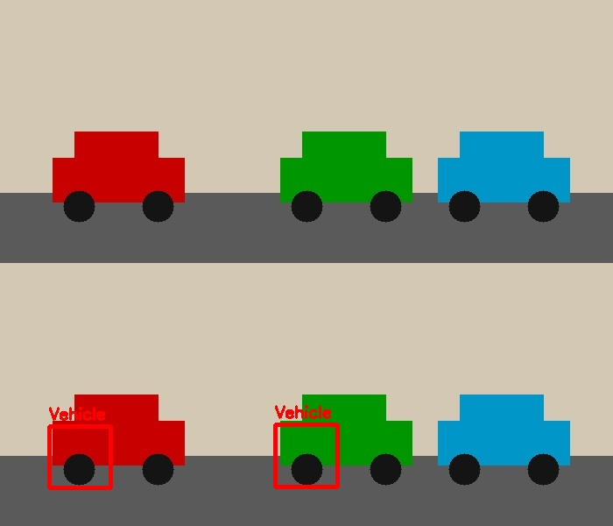
Fig. 39 — Output of Experiment 39: Vehicle Detection in a Video Frame using OpenCV.
RESULT
Detect vehicles (cars) in a video frame/image using a pre-trained Haar Cascade classifier for cars — completed successfully, as demonstrated in the output shown above.

